**A REPORT**

**ON**

**Send Updates using Logic App on Microsoft Azure**

Submitted in partial fulfillment of the requirements

for the award of the Degree of

**Bachelor of Technology**

**of**

**Poornima University, Jaipur**



**Submitted By:**

**Muskan Chaudhary : 2017PUSETBCCX05689**

**Mohit Soni : 2018PUSETBCCX06516**

**Amit Gadia : 2018PUSETBCCX06991**

**Shivani Maliwal : 2017PUSETBCCX05754**

**M. Junaid Mansuri : 2017PUSETBCCX05807**

**IIIrd Year, Computer Engineering(CT & IS )**

**Submitted To:**

**Dr. Nitesh Kaushik, Asst. Professor**

**Department of Computer Engineering** **School of Engineering & Technology, Poornima University Ramchandrapura, Sitapura Ext., Jaipur, Rajasthan**

**Session: 2019-20**

**ACKNOWLEDGEMENT**

We have undergone a project development which was meticulously planned and guided at every stage so that it became a life time experience for us. This could not be realized without the help from numerous sources and people in the Poornima University.

We are thankful to **Dr. Manoj Gupta, ProPresident, Poornima University** for providing us a platform to carry out this activity successfully.

We are also very grateful to **Mr. Ravi Godara (HOD, Computer Engineering)** for his kind support and guidance.

I would like to take this opportunity to show our gratitude towards **Dr. Nitesh Kaushik & Mr. Tushar Mittal** who helped us in successful completion of my seminar. They have been a guide, motivator & source of inspiration for us to carry out the necessary proceedings for completing this project and related activities successfully and grateful for their guidance and support. We are thankful for their kind support and providing us expertise of the domain to develop the project.

We would also like to express our hearts felt appreciation to all of our friends whom direct or indirect suggestions help us to develop this project and to entire team members for their valuable suggestions.

Lastly, thanks to all faculty members of Department of Computer Engineering for their moral support and guidance.

**Muskan Chaudhary**

**Mohit Soni**

**Amit Gadia**

**Shivani Maliwal**

**M. Junaid Mansuri**

iii

|  |  |
| --- | --- |
|  | **2019-20** |
|  |  |

**Abstract**

**Azure Logic Apps** is a cloud service that automates the execution of your business processes. You use a graphical design tool called the Logic Apps Designer to arrange pre-made components into the sequence you need. The Designer sends a definition of your workflow to the Logic Apps execution engine. The execution engine launches your app when conditions are right and manages the compute resources needed to run it.

To reach this goal, we will perform the following steps:

* Create a Resources Group
* Create a Action Group
* Create a Logic App
* Create Webhook
* Bind Logic App to Action Group

**Poornima University, Jaipur** **B. Tech. , Computer Engineering(CT & IS)**

|  |  |
| --- | --- |
|  | **2019-20** |
|  |  |

**TABLE OF CONTENTS**

|  |  |  |  |
| --- | --- | --- | --- |
| **Cover Page** | |  | **i** |
| **Acknowledgement** | |  | **ii** |
| **Abstract** |  |  | **iii** |
| **Table of Contents** | |  | **iv** |
| **List of Tables** | |  | **v** |
| **List of Figures** | |  | **vi** |
| **Chapter 1- Introduction………………………………………….** | | **1-2** | |
| 1.1 | Aims and Objectives……………………………………………………. | | 1 |
| 1.2 | Scope……………………………………………………………………. | | 1 |
| 1.3 | Technology used…………………………………………………….. |  | 1 |
| 1.4 | Technical Requirements…………………………………………………. | | 2 |
| **Chapter 2- About Technology ………………………………..** | | **3-5** | |
| 2.1 | Introduction ……………………………………………………………3 | |  |
| 2.2 | History……………………………………………………………… |  | 3 |
| 2.3 | Key Components…………………………………………………………4 | |  |
| 2.4 | Current Trends in Today’s World ………………………………………… | | 5 |
| **Chapter 3- Technological Details/Architecture …………..…..** | | **6-33** | |
| 3.1 | Technology Overview…..………………………………………………. | | 8 |
| 3.2 | Design……….……………………………………………............ | 10 |  |
| 3.3 | Architecture…………………………………………………….......….. 20 | |  |
| 3.4 | Implementation……………………………………………………… | 25 | |
| 3.5 | Applications ………..…………………………………………… | 33 | |
| **Chapter 4-Miscellaneous, Conclusion & Future scope…………** | | **34-37** | |
| 4.1 | Conclusion…………………………………………………………. | 36 | |
| 4.2 | Future Scope…………………………………………………… | 37 | |

**References……………………………………………………………….**



**Poornima University, Jaipur** **B. Tech. , Computer Engineering(CT & IS)**

|  |  |
| --- | --- |
|  | **2019-20** |
|  |  |

**Chapter 1**

**Introduction**

* 1. **Aims and Objective:**

Azure Logic Apps gives you pre-built components to connect to hundreds of services. You use a graphical design tool to put the pieces together in any combination you need and Logic Apps will run your process automatically in the cloud. Here, you'll see how Logic Apps automates these types of business processes. You'll also learn a bit about how they work behind the scenes. The goal is to automate the process of sending alerts, and notifications over email.

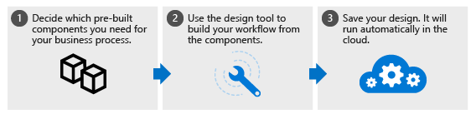

**1.2 Scope:**

The Logic Apps model is extensible. If there isn't a pre-built component for the service you need, you can create your own. You can also run custom code in an Azure Function that you invoke from your app.

If we had to describe the goal of Logic Apps in one word, we'd choose integration. Logic Apps helps you join disparate services to implement a workflow. Your job is to use the Logic Apps Designer to arrange the components into the sequence you need. For most apps, you won't need to write any code and you can be up and running in minutes.

* 1. **Technology used**

**Microsoft Azure** is a [cloud computing](https://en.wikipedia.org/wiki/Cloud_computing) service created by [Microsoft](https://en.wikipedia.org/wiki/Microsoft) for building, testing, deploying, and managing applications and services through Microsoft-managed [data centers](https://en.wikipedia.org/wiki/Data_center). It provides [software as a service (SaaS)](https://en.wikipedia.org/wiki/Software_as_a_service), [platform as a service (PaaS)](https://en.wikipedia.org/wiki/Platform_as_a_service) and [infrastructure as a service (IaaS)](https://en.wikipedia.org/wiki/Infrastructure_as_a_service) and supports many different [programming languages](https://en.wikipedia.org/wiki/Programming_language), tools, and frameworks, including both Microsoft-specific and third-party software and systems.

**Azure Logic Apps** is a cloud service that helps you schedule, automate, and orchestrate tasks, business processes, and workflows when you need to integrate apps, data, systems, and services across enterprises or organizations.

**PROJECT TECHNOLOGY :**

## Automate the process of sending custom alerts, and notifications over mail

Azure Logic App helps you build an app which will grab all the alerts for you, and will help building a custom dynamic notification, which will be sent over mail.

**Trust Factor :**

* Microsoft invests more than USD 1 billion annually on cyber security research and development
* Azure employ more than 3,500 security experts completely dedicated to your data security and privacy.
* Azure has more compliance certifications than any other cloud provider.
  1. **Technical Requirements**
* **---------------------------------------------------------------------------------------------------**
* **---------------------------------------------------------------------------------------------------**
* **---------------------------------------------------------------------------------------------------**
* **---------------------------------------------------------------------------------------------------**
* **---------------------------------------------------------------------------------------------------**
* **---------------------------------------------------------------------------------------------------**

### Client operating system support with Azure App

The following client operating systems are supported:

* Windows 7 (32-bit and 64-bit)
* Windows Server 2008 R2 (64-bit only)
* Windows 8.1 (32-bit and 64-bit)
* Windows Server 2012 (64-bit only)
* Windows Server 2012 R2 (64-bit only)
* Windows Server 2016 (64-bit only)
* Windows 10
* Mac OS X version 10.11 or above
* Linux (StrongSwan)
* iOS

**Poornima University, Jaipur** **B. Tech. , Computer Engineering(CT & IS)**

**Chapter 2**

**About Technology**

**2.1 Introduction**

**Azure Logic Apps** is a cloud service that automates the execution of your business processes. You use a graphical design tool called the Logic Apps Designer to arrange pre-made components into the sequence you need. The Designer sends a definition of your workflow to the Logic Apps execution engine. The execution engine launches your app when conditions are right and manages the compute resources needed to run it.

The power of Logic Apps comes from the diversity of the pre-built components and their ability to work together. The components let you connect to hundreds of external services. The following illustration shows a few of the services you can use in your Logic App.

The Logic Apps model is extensible. If there isn't a pre-built component for the service you need, you can create your own. You can also run custom code in an Azure Function that you invoke from your app.

If we had to describe the goal of Logic Apps in one word, we'd choose integration. Logic Apps helps you join disparate services to implement a workflow. Your job is to use the Logic Apps Designer to arrange the components into the sequence you need. For most apps, you won't need to write any code and you can be up and running in minutes.

**2.2 History**

Logic App was developed to overcome the problem of managing and reporting the collected data to the assigned personnel. To achieve the above task an employee has to analyze all the logs which include millions of lines of activities happening on a server. The employee then have to select and categorize all the logs according to the categories. Then he has to send/ notify all the assigned personnel about the activity.

As the cloud industry grew doing the above task became more and more difficult. And cloud providers needed a simple solution for the problem. Then comes the Logic Apps, it is a fast, easy to create app, which let you design an action based on a specific trigger.

The power of Logic Apps comes from the diversity of the pre-built components and their ability to work together. The components let you connect to hundreds of external services. The following illustration shows a few of the services you can use in your Logic App.

**2.3 Key Components**

* Azure Logic App
* Azure Monitor Alerts
* Azure Log Analytic Workspace
* Azure Action Groups

**2.4 Current Trend**

At its core, Azure Logic Apps is a serverless workflow engine service available in the cloud and a key part of Azure’s Platform as a Service (PaaS) feature-set. It stands out from traditional, bespoke workflow applications by offering a ton of features out of the box that significantly streamline the workflow development process.

Top 7 reasons why you should be using Logic Apps as your integration platform.

* It's a cost-effective integration solution
* Drag-and-drop design for better business workflows
* It's a scalable and lightweight service
* 200+ enterprise connectors out of the box
* In-built monitoring for faster historical insights
* Supports B2B and enterprise messaging integration
* Use existing BizTalk and on-premises investments

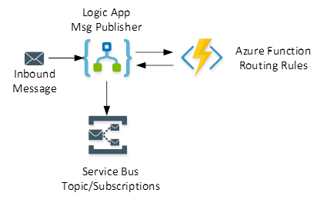

Poornima University, Jaipur B. Tech. , Computer Engineering

|  |  |
| --- | --- |
|  | **2019-20** |
|  |  |

**Chapter 3**

**Technological Details/**

**Architecture**

**3.1 Technology Overview**

Every logic app workflow starts with a trigger, which fires when a specific event happens, or when new available data meets specific criteria. Many triggers provided by the connectors in Logic Apps include basic scheduling capabilities so that you can set up how regularly your workloads run. For more complex scheduling or advanced recurrences, you can use a Recurrence trigger as the first step in any workflow.

Integration Service Environment (ISE) is where users can run their Logic App which can interact with the services as VMs secured inside the Azure Virtual Network. The Logic App and its storage will be isolated from public Logic App services. Hence isolating the Azure Logic Apps will improve its performance too.

**3.2 Design**

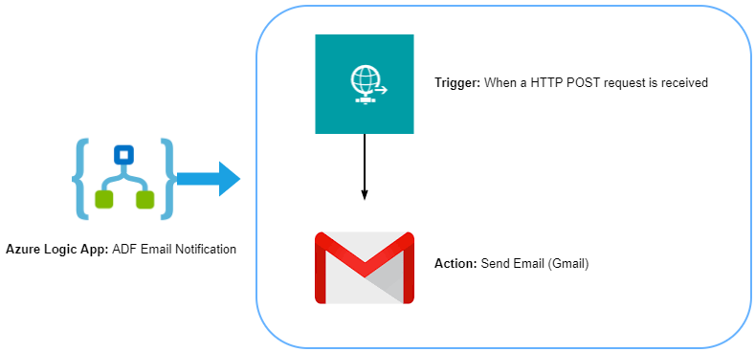

**3.3 Architecture**

**Components of the Logic App:**

* The Connector
* 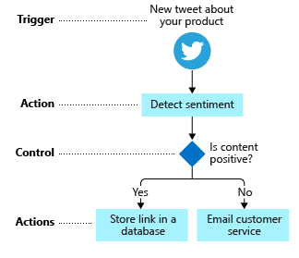The Trigger
* The Action

### Connector

Connectors in Logic Apps are used to perform certain actions or processes. These connectors are designed to connect and work with user data. There are numerous connectors available for Azure Logic Apps including Enterprise connectors. Users can use pre-defined connectors as well as create their own custom connectors. It is also possible to define connectors using ARM templates. Connectors in Azure Logic Apps may act either as actions or as triggers.

### Action

Actions are the steps those run once initiated by the trigger. Whenever a Logic App gets triggered, there will be a succession of actions those run to complete the workflow. Actions are processes those will perform the designated business task based on the data provided by the user. Users can select the required action from the extensive set of actions available in the connector repository.

### Trigger

Triggers are the starting point for a Logic App workflow that will fire when new data or event that meets the trigger condition occur. Connectors in Logic Apps itself provide various triggers. Custom triggers can also be created using custom connectors. Users can also define multiple triggers in a Logic App.

**3.4 Implementation**

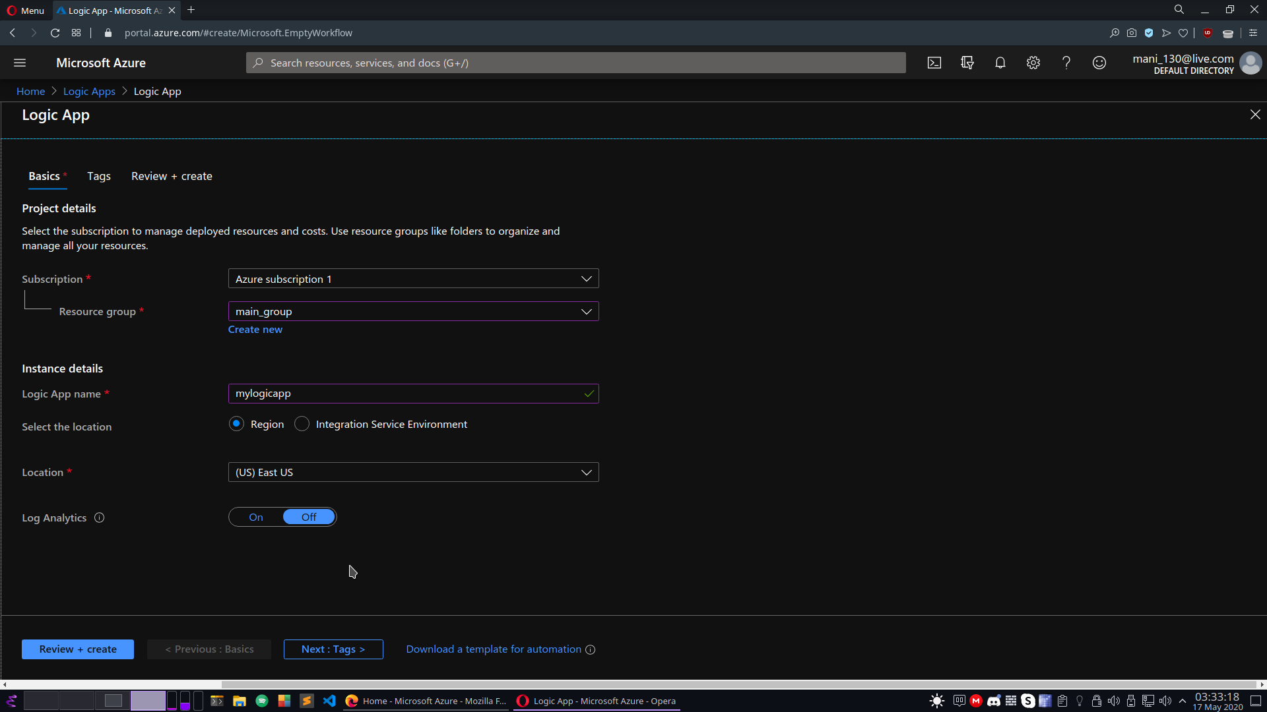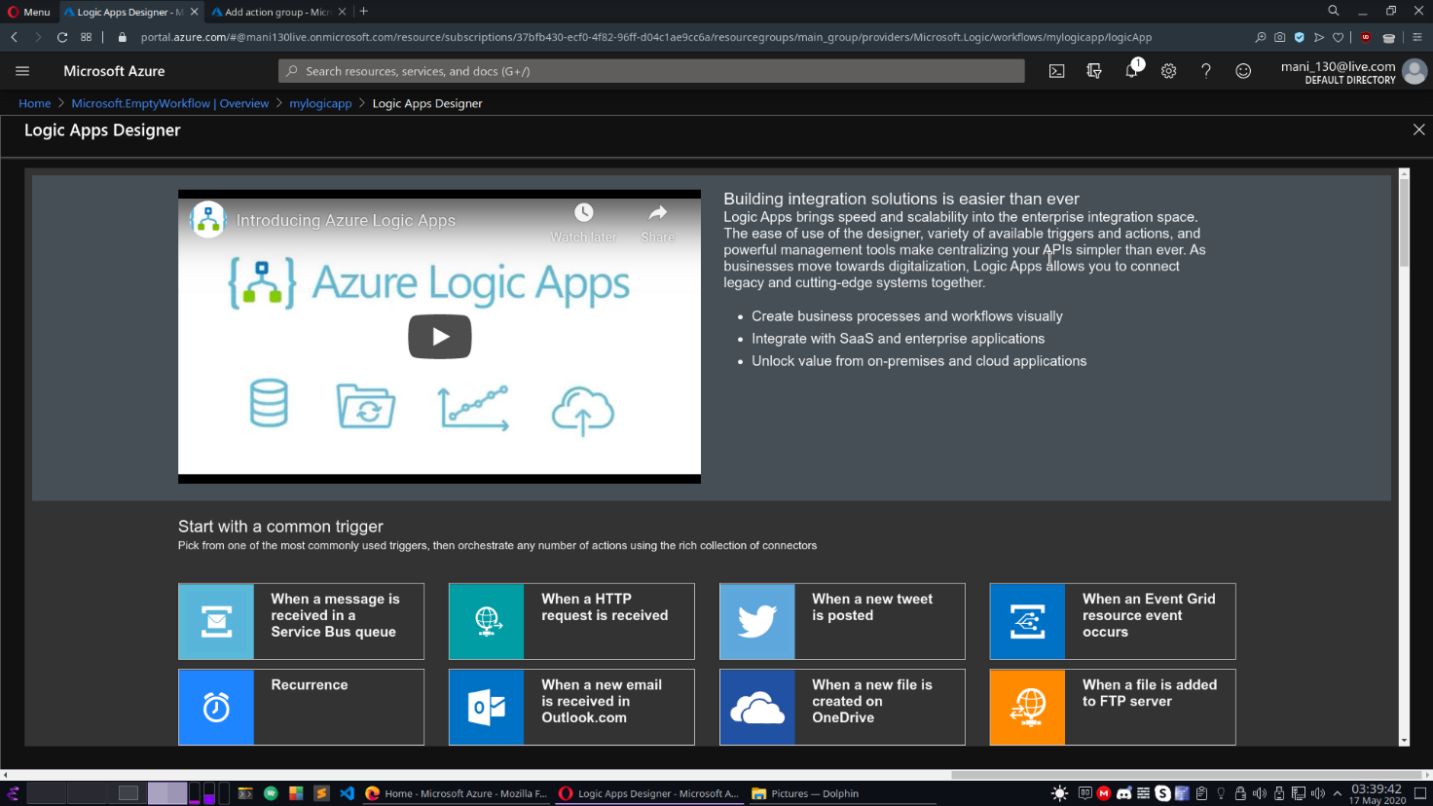

**Creation of logic app through azure portal**

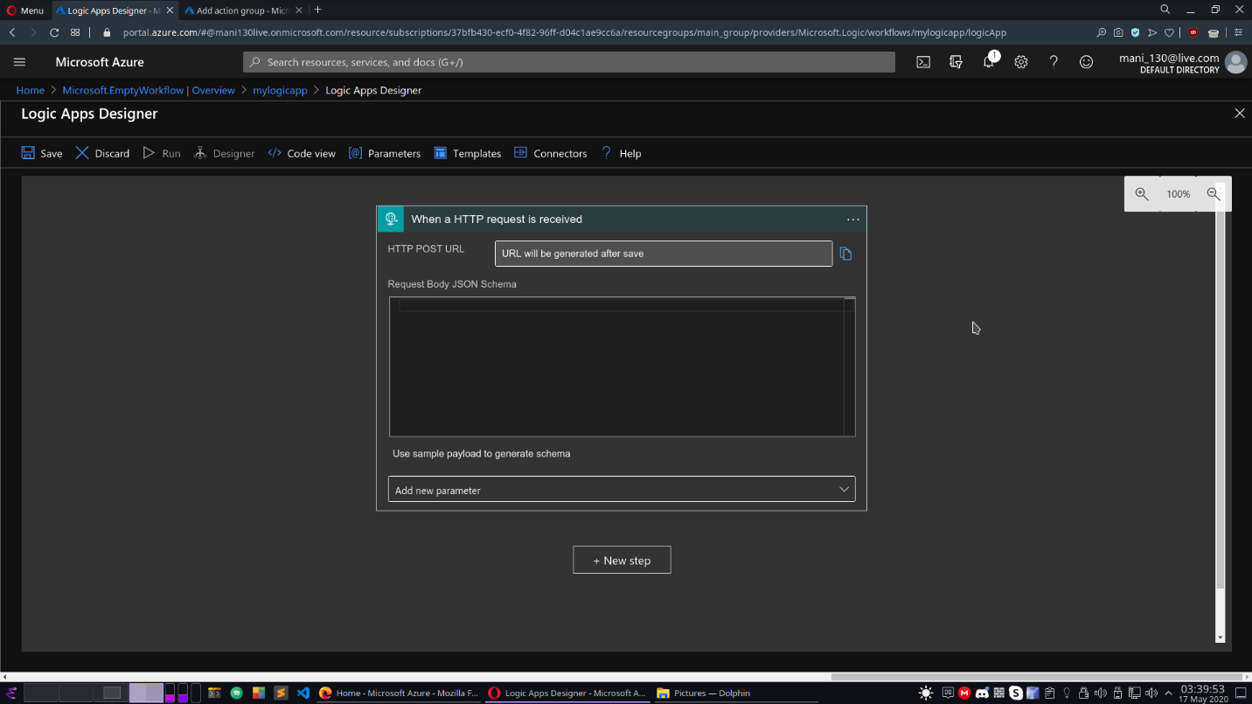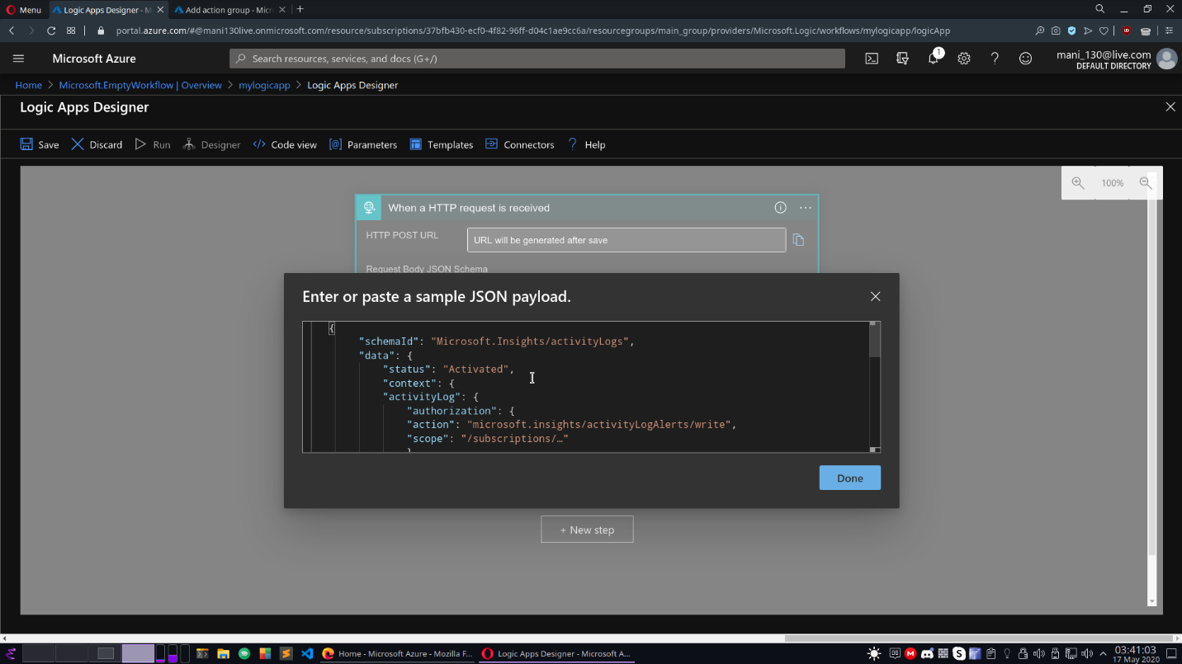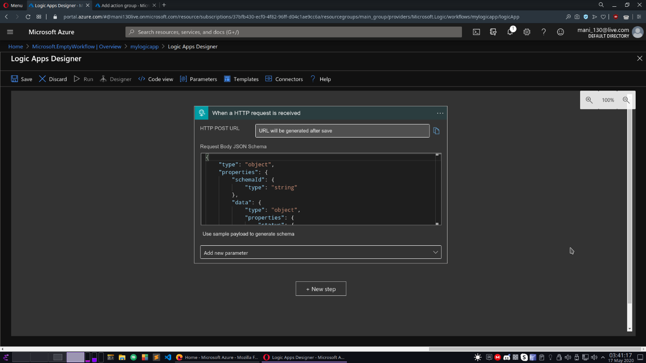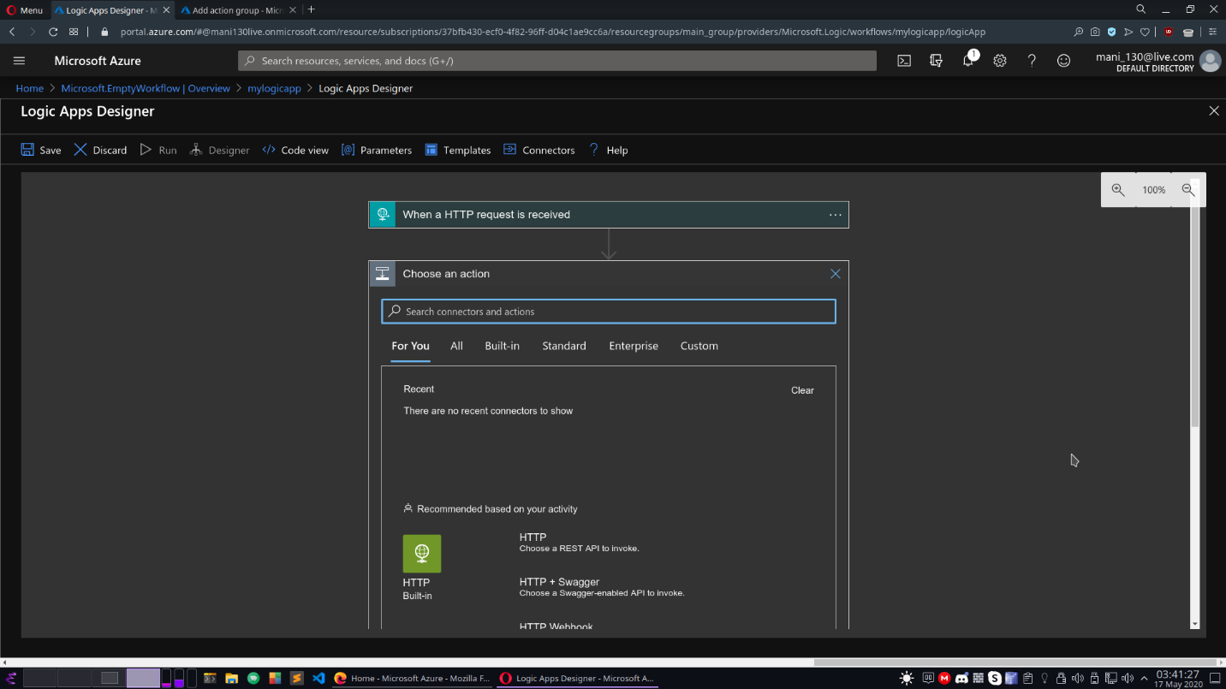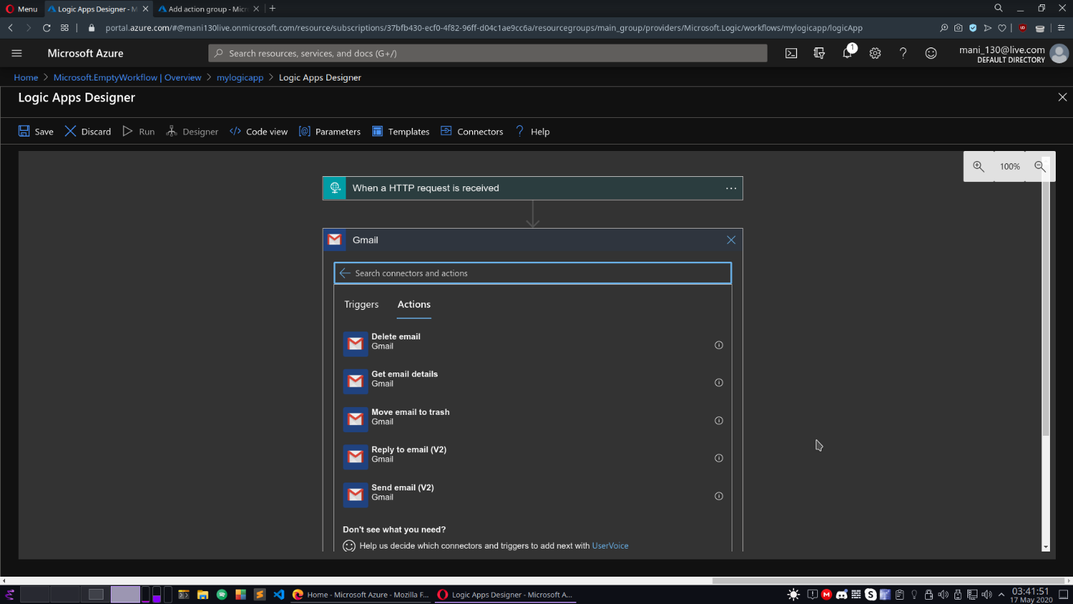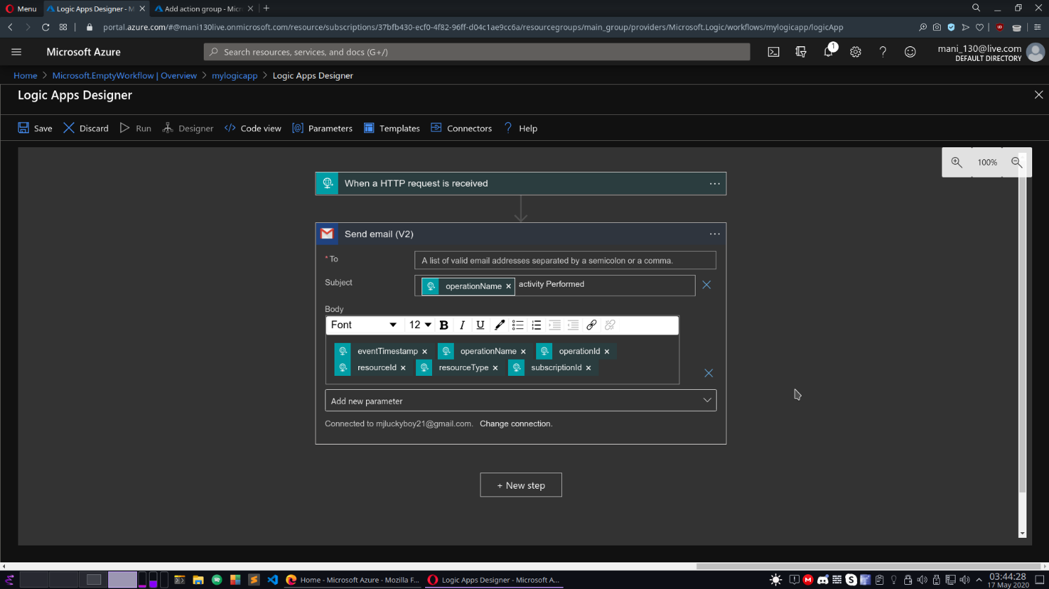

**Log analytics workspace creation for collection of administrative tasks for setting an alert rule to monitor logs.**

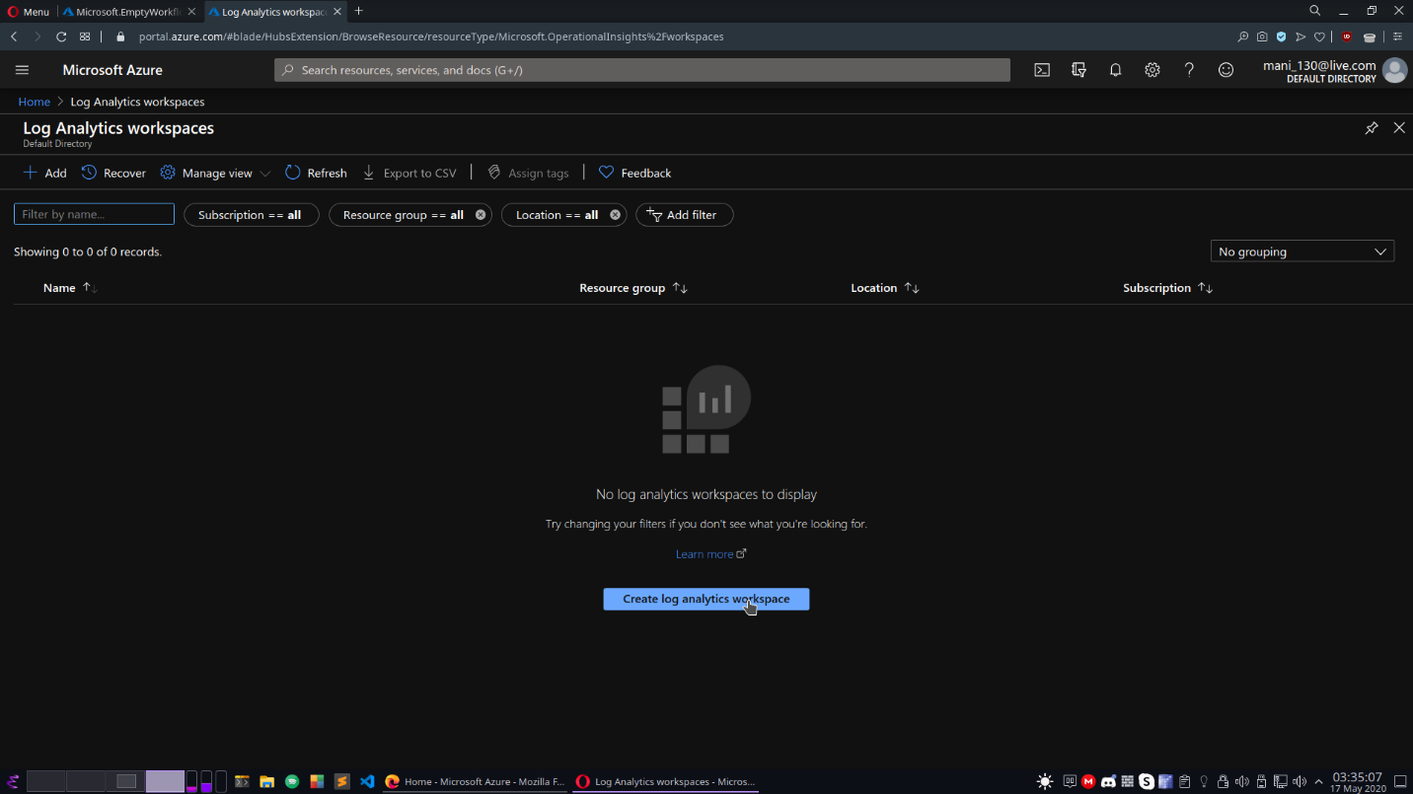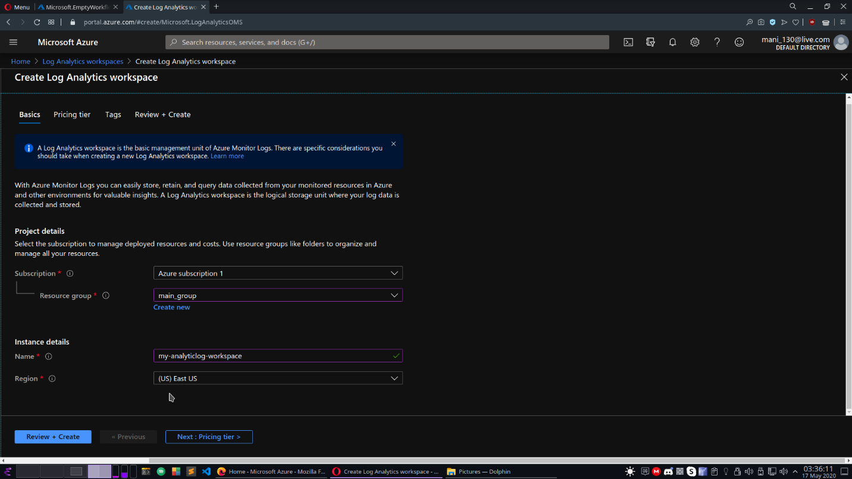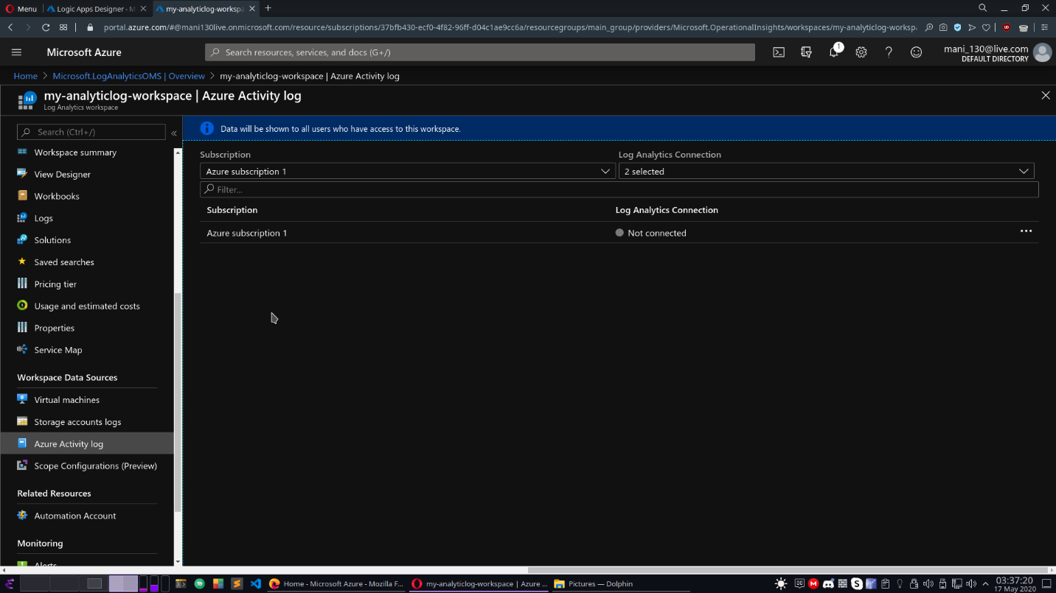

**Setting up an alert rule to monitor the workspace and call the action group upon confirmation:**

1. **Rule wil monitor the resource and upon changing state of workspace ie logs, it will call a action group**
2. **Action group contains group of action such as logic app, webhooks, ie and will call all the actions listed.**

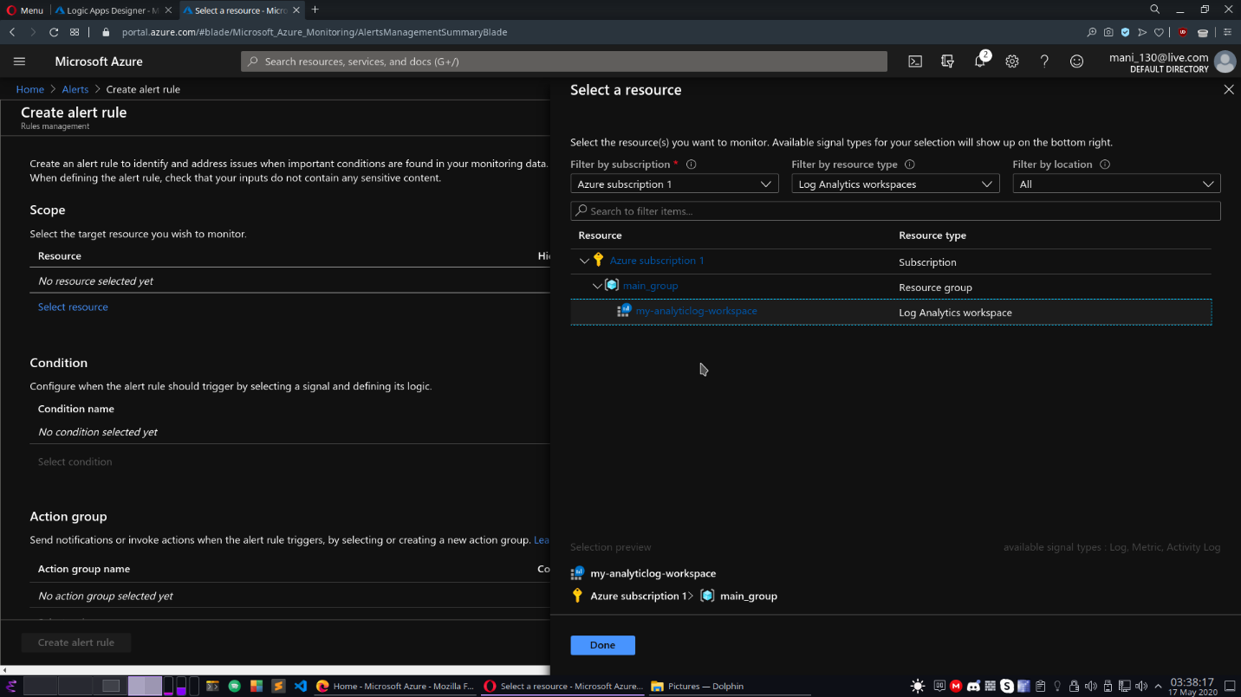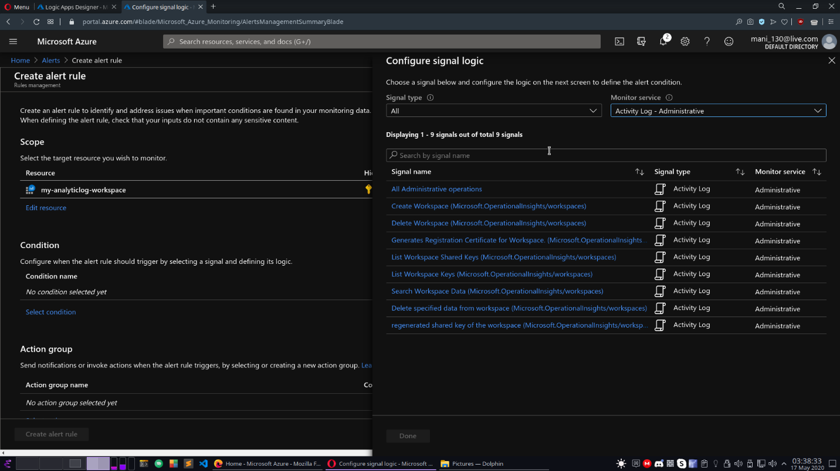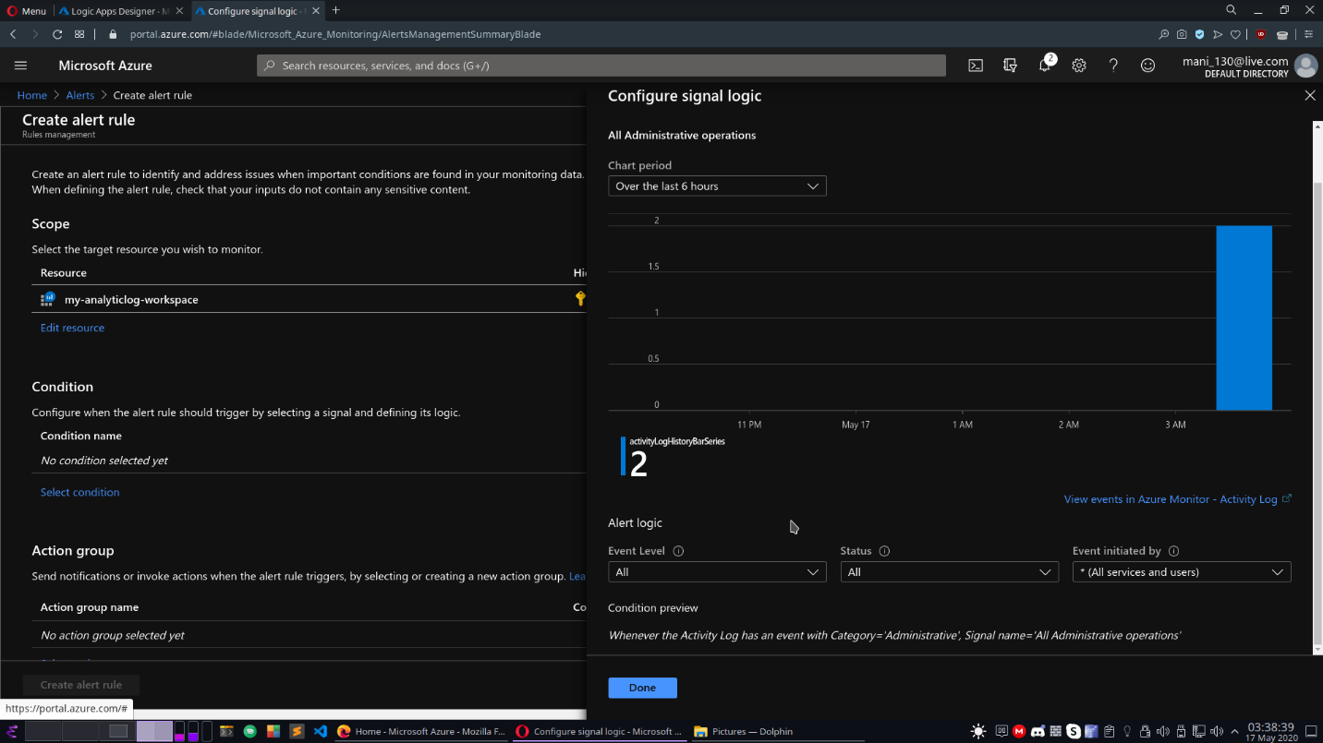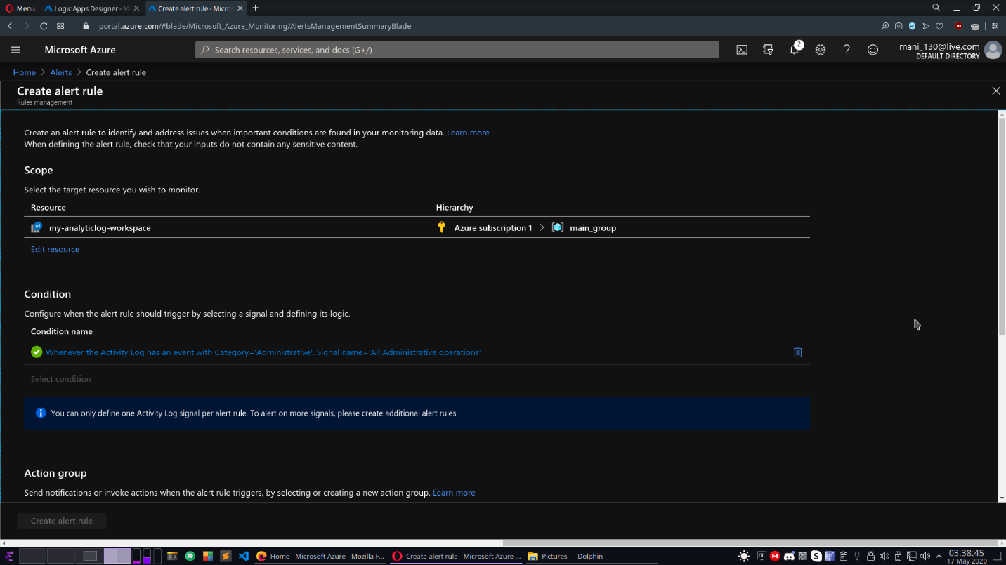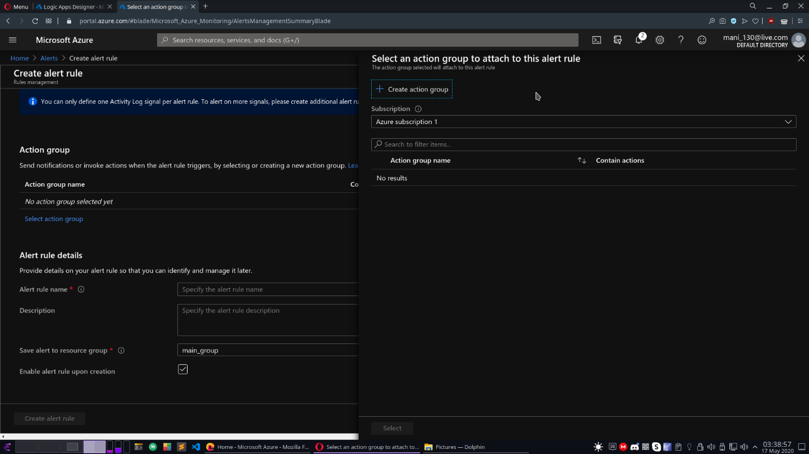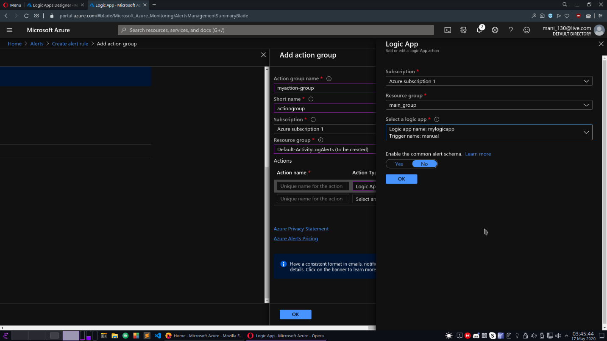

**Selection of logic app as action in action groups.**

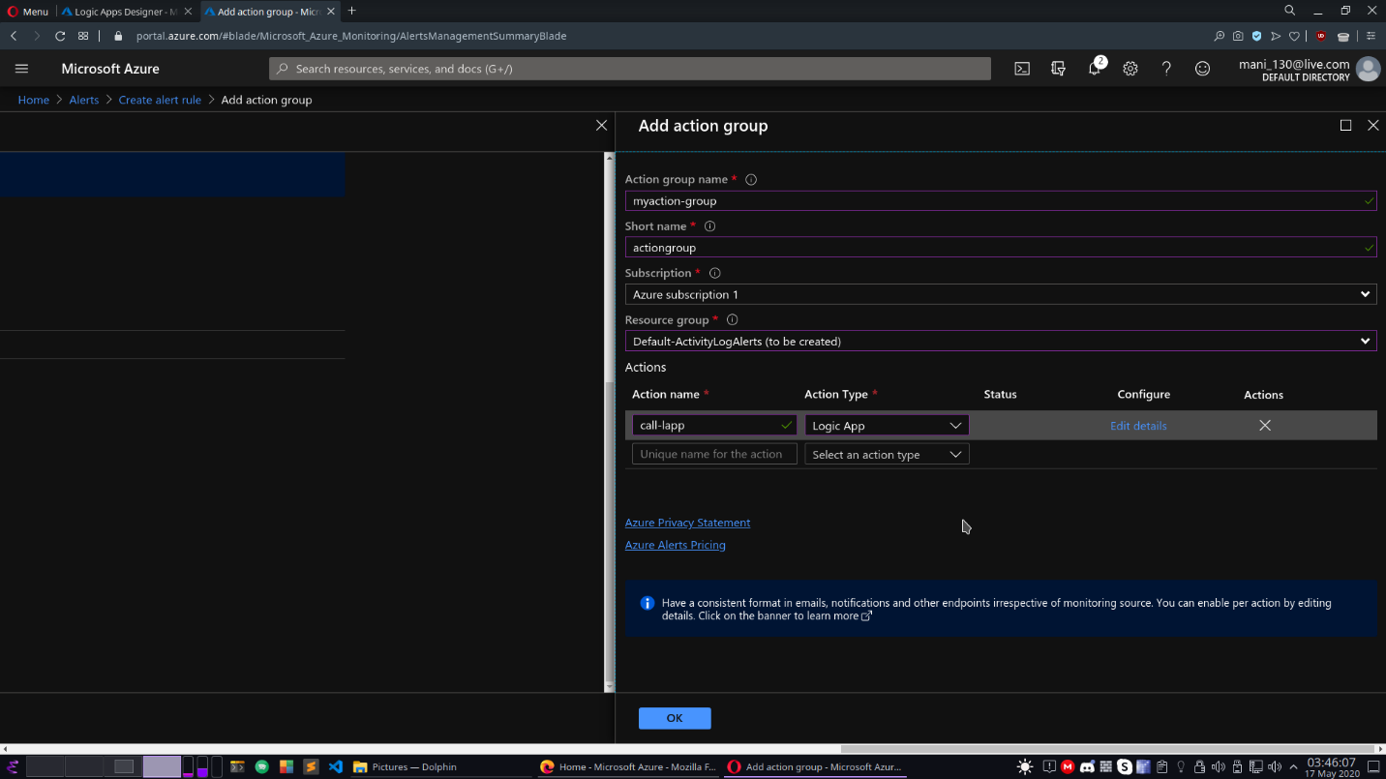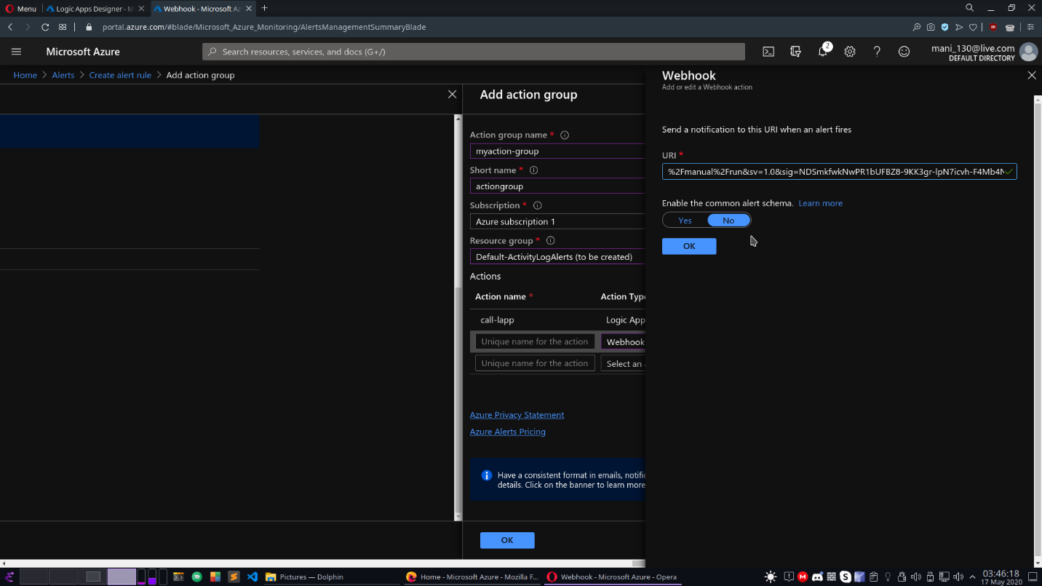

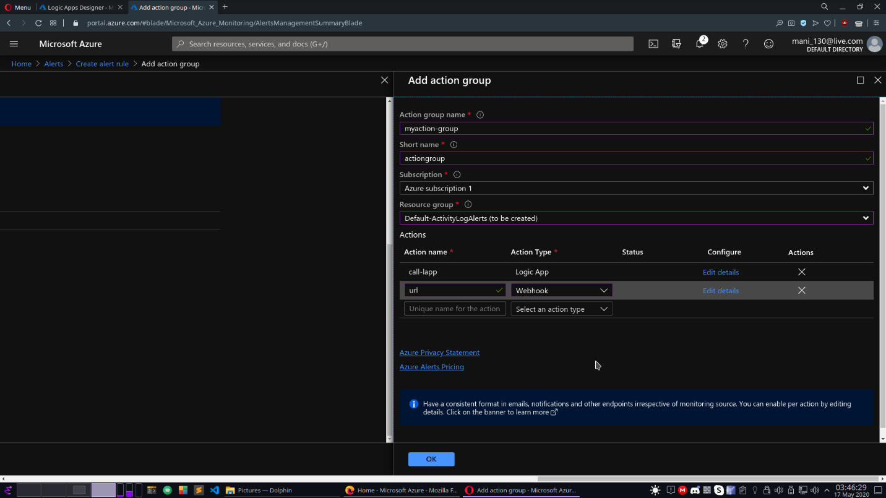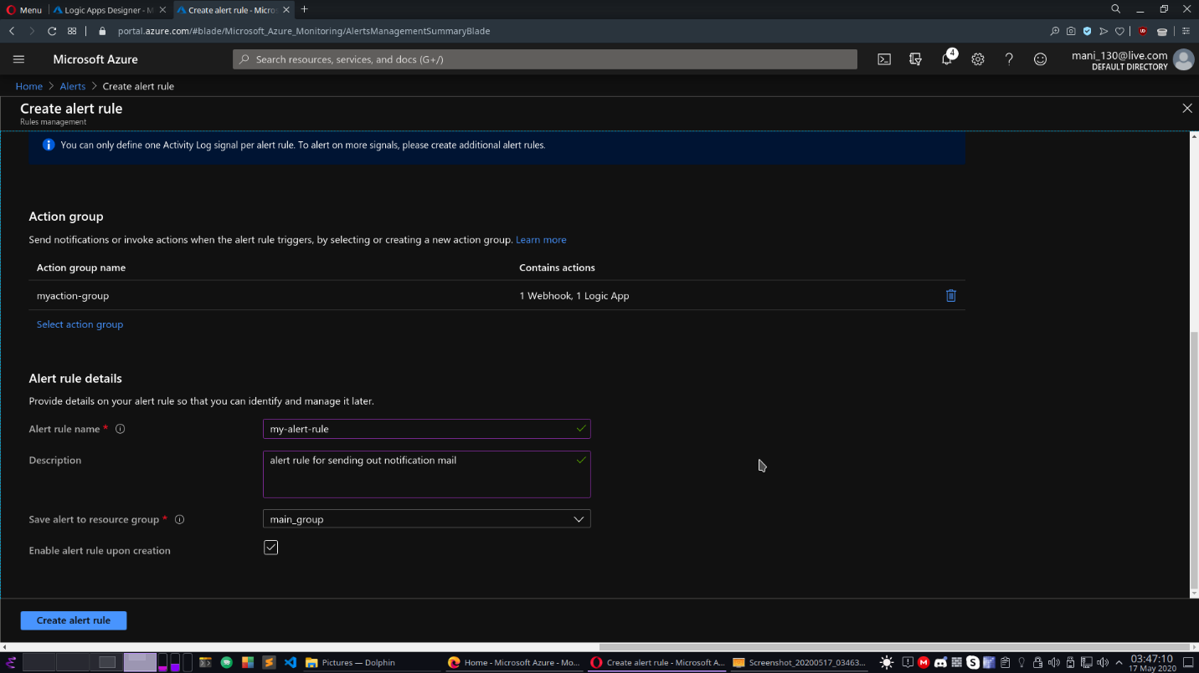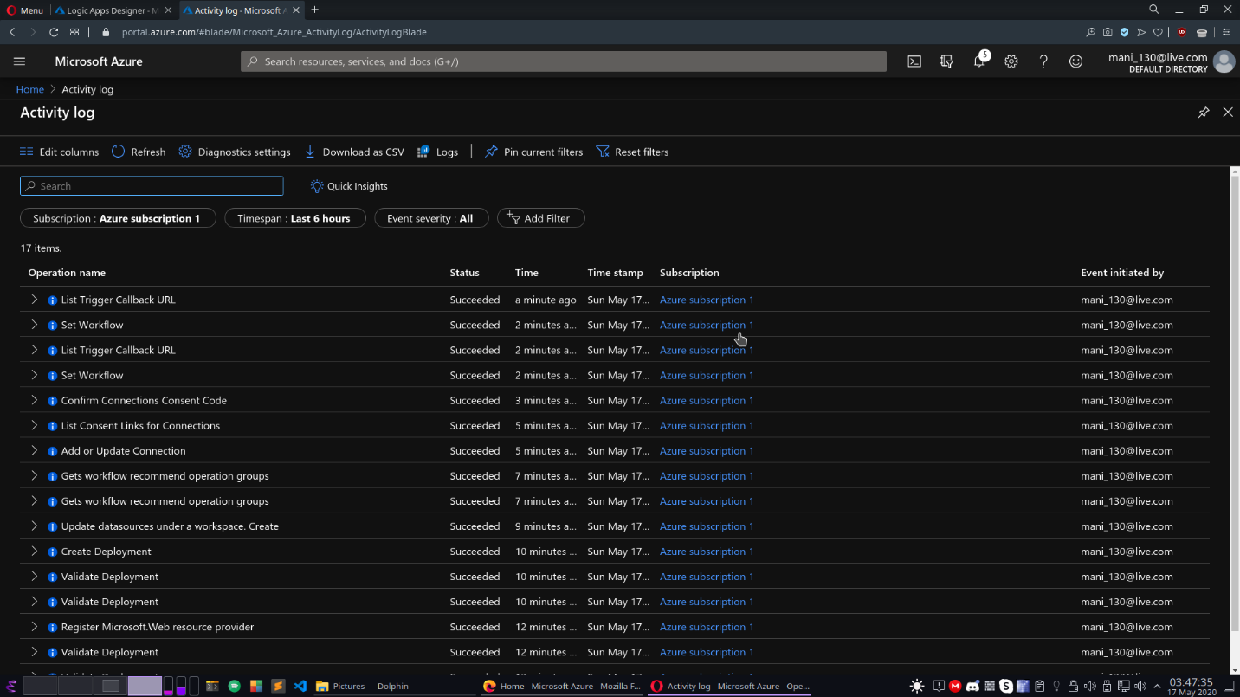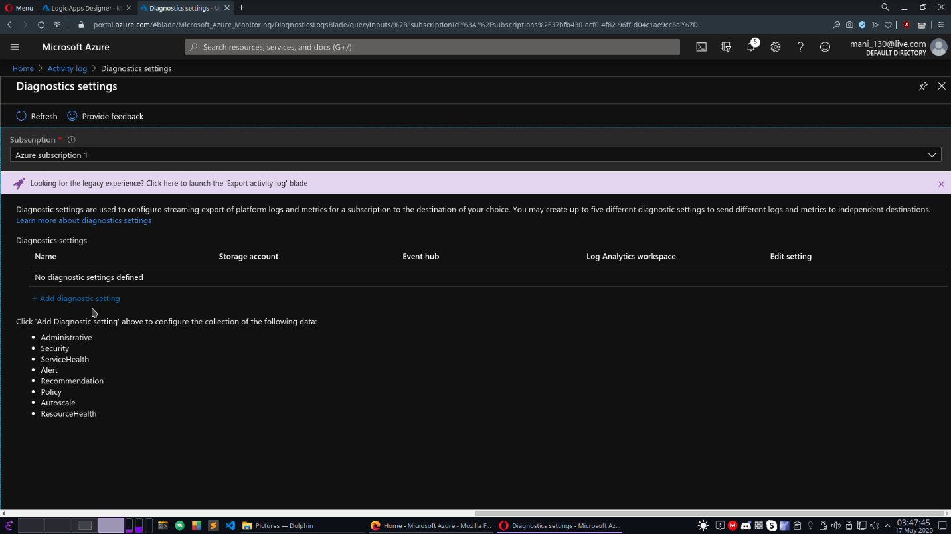

**Connection of workspace to azure activity to collect azure administrative logs and redirect them to log analytic workspace.**

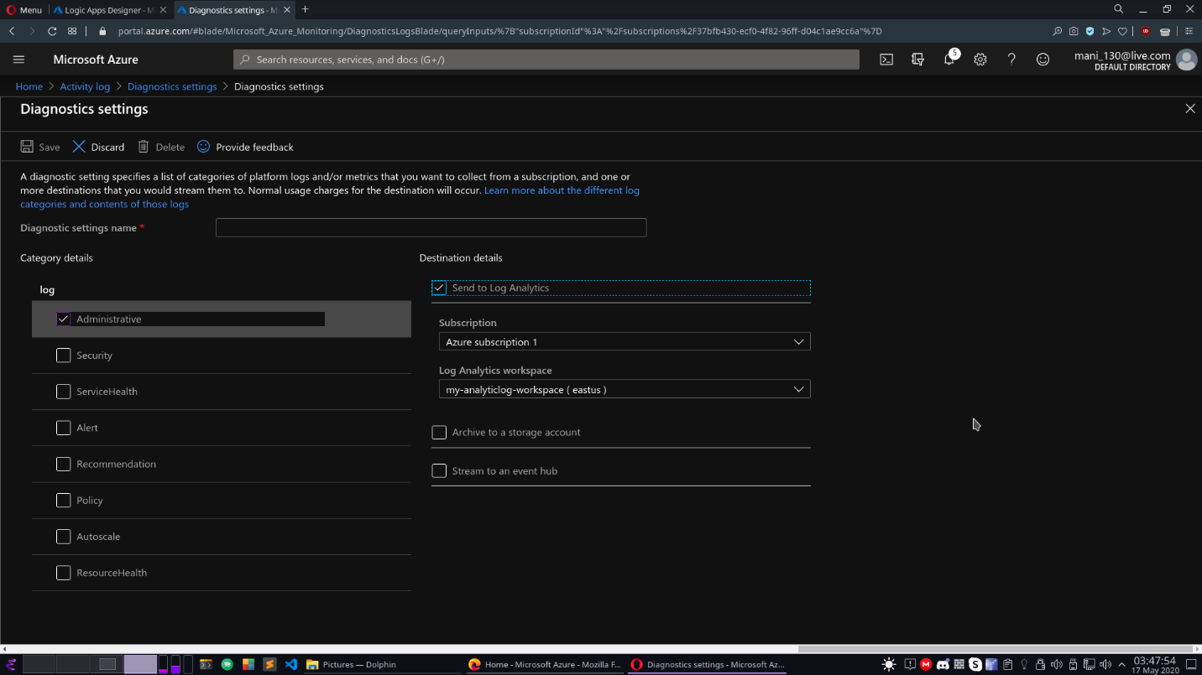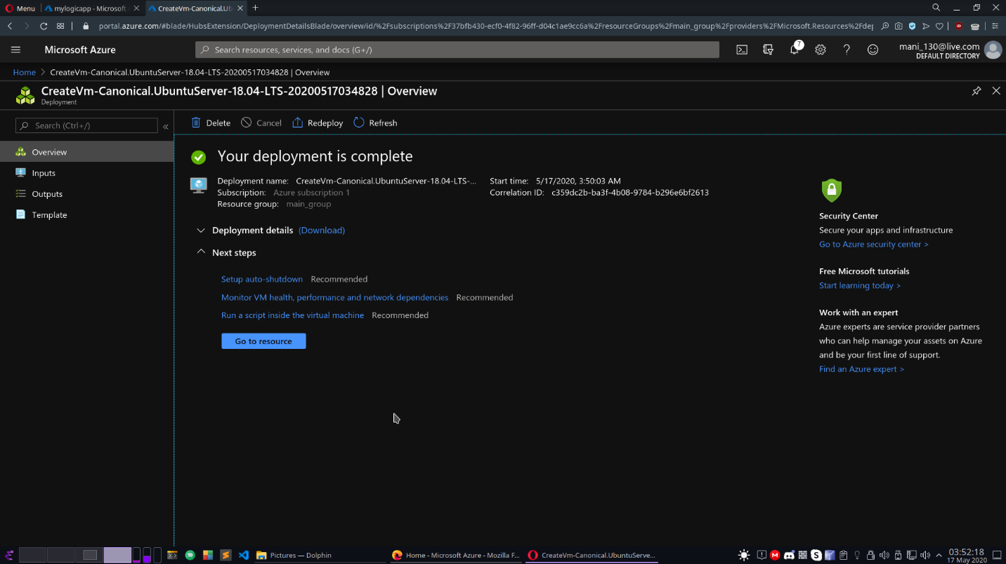

**Setting up cost alert to notify app-alert-group to call logic app.**

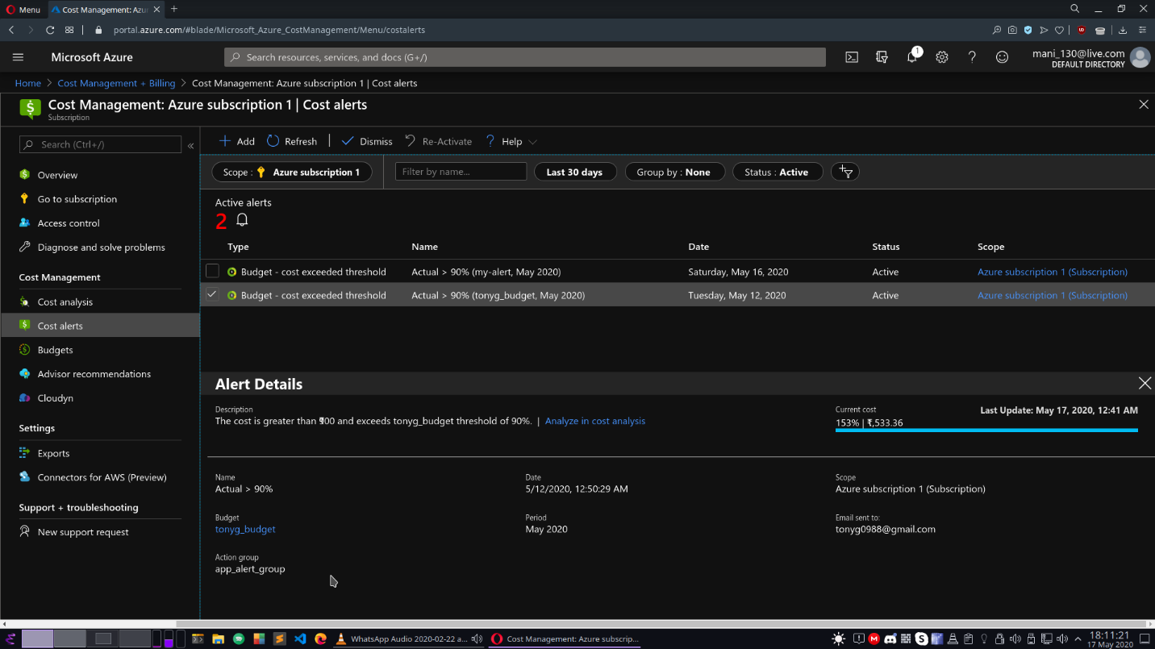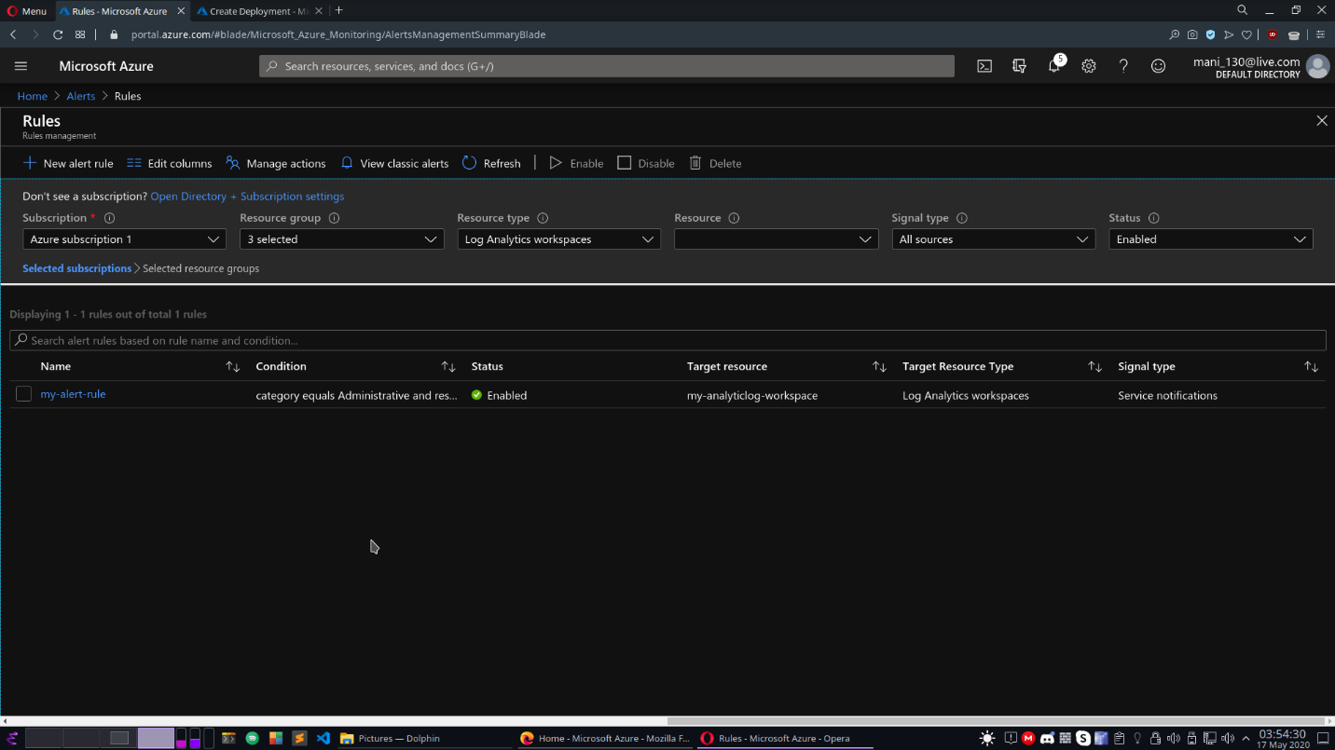

**Deployment of a resource to check the mailing system, in our case A VM will generate administrative logs such as creation of disks, and other resources.**

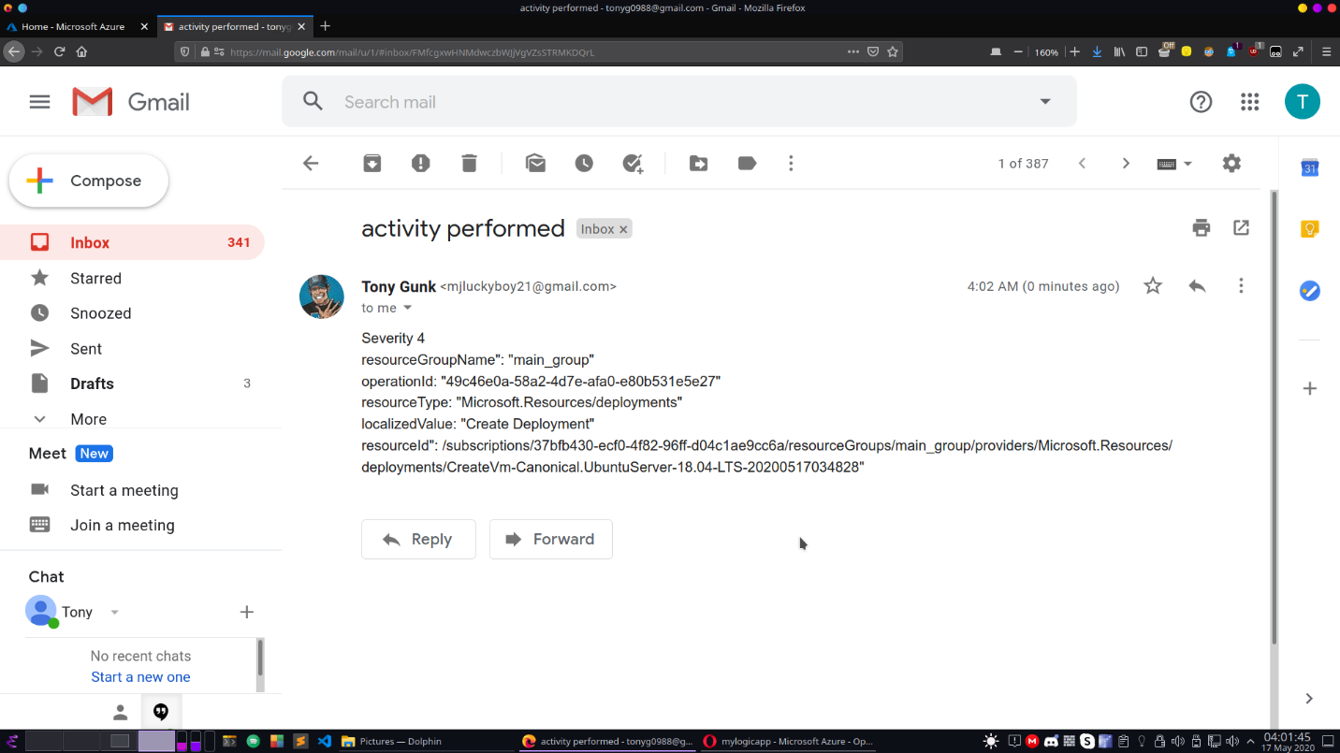

**Mail received via authenticated mail containing resources information selected during action option of logic app. These details are fetched via the POST URL method passed during trigger of logic app via action groups.**

**3.5 Applications**

1. It's a cost-effective integration solution

Azure Logic Apps is one of the most cost-effective enterprise integration platforms on the market.The service requires zero upfront setup costs, and like other Azure services, you don’t have to pay for infrastructure maintenance because it’s fully managed for you by Microsoft.

Another often overlooked benefit is that all users of Logic Apps can develop and test integration features prior to deploying their workflows, without worrying about any additional costs.

1. Drag-and-drop design for better business workflows

Azure Logic Apps makes creating workflows simple with its interactive, drag-and-drop design interface using the in-built Logic Apps Designer. Available in Azure Portal via your standard Web browser, you can build automated business processes and system integrations with minimal coding using hundreds of pre-built connectors – and it automatically generates the code in the background.

1. 200+ enterprise connectors out of the box

Azure Logic Apps is one of the most cost-effective enterprise integration platforms on the market.The service requires zero upfront setup costs, and like other Azure services, you don’t have to pay for infrastructure maintenance because it’s fully managed for you by Microsoft.

Another often overlooked benefit is that all users of Logic Apps can develop and test integration features prior to deploying their workflows, without worrying about any additional costs.

1. It's a scalable and lightweight service

Azure Logic Apps is flexible on account of its scalability as a cloud-based, serverless computing service.Traditional enterprise application development usually involves plenty of worry about hosting, monitoring and scaling, but serverless solutions like Azure Logic Apps takes care of all of these separate worries in a single managed service.With serverless compute, the platform automatically scales out your workflow runs with the resources it needs, and there’s no need to provision VMs. Because the cloud can scale from nothing to handle tens of thousands of concurrent functions within seconds, you can match changing events and triggers in real-time, without any manual configuration.

1. Supports B2B and enterprise messaging integration

Azure Logic Apps provides business-to-business (B2B) integration features via its Enterprise Integration Pack that allow users to exchange messages electronically, even if they use different formats and protocols. The pack decodes inputs received from your enterprise apps, processes it using workflows and encodes the output into a standard format target systems can interpret.

1. Use existing BizTalk and on-premises investments

If your business is heavily aligned with BizTalk, Azure Logic Apps offers an easy way to leverage your existing processes implemented with the service by using Azure BizTalk Server. It’s a free separate download added to BizTalk Administration once installed, and other adapters for other systems are available.

**Poornima University, Jaipur** **B. Tech. , Computer Engineering(CT & IS)**

|  |  |
| --- | --- |
|  | **2019-20** |
|  |  |

**Chapter 4**

**Conclusion & Future scope**

**4.1 Conclusion**

Azure Logic Apps is a powerful, extensible and user friendly platform for developing enterprise integration applications. In my opinion, it can be used extensively for scenarios we just saw.

With the expanded capabilities of data integration platforms like Azure Logic Apps, we can now reduce our historic dependency on middleware solutions like BizTalk and connect directly to our SaaS solutions and integrate better, smarter workflows from one convenient place - the cloud.

Azure Logic Apps is one of the best workflow options to extend your integration platform to the cloud. It seamlessly connects your apps and services, whether on-premises or in the cloud, and brings your business workflows together in one place for additional consistency and scalability.

Azure Logic Apps is constantly being updated with new connectors, features and templates to continuously enhance your cloud integrated workflows. As every customer is looking to adopt Cloud based solutions, Azure Logic Apps is a great Cloud based integration solution for your business.

**4.2 Future scope**



Almost everything in the digital world is connected to the cloud in some way or another — unless it’s specifically kept in local storage for security reasons. As tech giants and startups find new ways to organize, process and present data cloud computing will become a more and more integral part of our lives.

In the current cloud market the benefits of leveraging the infrastructure of a large cloud provider can be beneficial in many ways. The ability to scale rapidly works well for companies with high growth demands. With these benefits come some limitations. Your experience is limited by the speed and reliability of your internet connection which can impact your business.



**Poornima University, Jaipur** **B. Tech. in Computer Engineering (CT & IS)**

|  |  |
| --- | --- |
|  | **2019-20** |
|  |  |

**REFERENCES**

The References taken for the development of this report and Project are:

www.youtube.com

[www.checkspoint.com](http://www.tutorialspoint.com/)

https://www.futureofeverything.io/future-of-cloud-computing/

https://docs.microsoft.com/en-us/learn/modules/intro-to-logic-apps/

https://docs.microsoft.com/en-us/azure/azure-monitor/

https://www.serverless360.com/azure-logic-apps

https://www.serverless360.com/blog/when-to-use-logic-apps-and-azure-functions

**Poornima University, Jaipur** **B. Tech. , Computer Engineering(CT & IS)**